The Path: A Journey of Success

Caitlin L. Gong

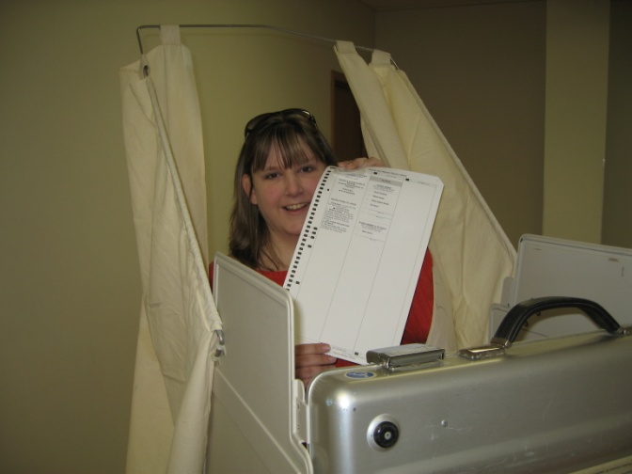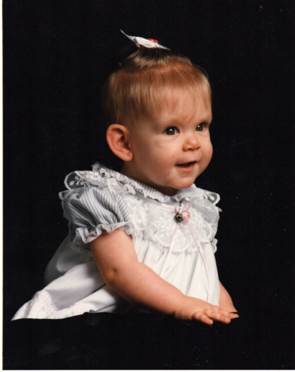

Nicole Cleveland is a young woman on her way to a very successful future. She was born with Turner Syndrome but that hasn’t stopped her from working to achieve great things. She has confronted any obstacles that have come her way with the help of a strong support system of family and friends and has illustrated that just because you have Turner Syndrome it doesn’t mean it has to define you.

While growing up she missed a lot of school because of her many doctors’ visits due to multiple ear infections. She mentioned that she had trouble in math and English and that it took her twice as long to complete her homework as her brother and friends. She was placed in special education classes in second grade to help her with math and English and continued in special education classes until she finished high school. Her parents tried to keep her active in clubs and activities and encouraged her participation in cheerleading, choir, pageants, acting classes, dancing classes, and after school programs which helped her to make a lot of friends. How did her classmates perceive her though because of her condition? She said, “Other than the few short jokes I got growing up, I was always treated just like everyone else and had a lot of friends. Very few people knew that I had it until I did a class report on it in high school once I opened up. It was a great feeling and I was not treated any differently.”

She found a great doctor when she was 7, Dr. John Shelso, who put her on growth hormone from ages 10-16 and low amounts of estrogen. She is now 5’1 and said that she feels somewhat like an average woman. She did, however, mention that she felt different at times and explained, “There are times, because I live with Turner Syndrome, that writing is hard. I know what I want to say but writing it down is hard. When I go to a concert or movie and have to move over because the person in front is too tall for me to see over, I notice. Driving a car is difficult for me. When I look in the mirror it hits me, I look like my friends so why is it so hard for me to do these things? I think I am here and I am special and God made me special and I know I am going to be okay.”

Nicole has also had to confront the fact that she is unable to have children. She has been told that in-vitro fertilization is an option but it is high-risk and has always planned to adopt. She said, “Being told that I can never have my own children at a young age broke my heart and was and still is the hardest part of living with Turner Syndrome. How do you tell the man that you will marry that you cannot give him a child? I, however, look at the glass half full and know there are many children in the world in need of good homes and a family and I want to be there for them like my family has always been there for me.”

Her life outside of dealing with her condition has been one of great success. In junior high school she was named Quota Club’s Outstanding Young Woman. Quota Club is an international service organization where members work to change the lives of deaf, hard-of-hearing, and disadvantaged women and children in local communities around the world. She also finished high school at the top half of her class and enrolled at Morningside College with a concentration in political science and journalism.

Once she completed college she ran for city council in her hometown of Sergeant Bluff, Iowa, and won a position. She was the youngest female member of the council in the town’s history. Nicole plans to run for state house in a few years and wants to have the state of Iowa declare February Turner Syndrome Awareness Month. In addition to this she said, “I would love to work on an email and letter campaign to state legislators across the country to increase funding for research and awareness because so many do not understand the emotional and physical issues behind this disorder. Others do not know I have it because I look like your average woman, but when I tell people I have Turner Syndrome they first ask what it is, then they say I never would have guessed that you had a health issue like this. I look younger than I am so sometimes it is hard to get the respect of others, but once I work with them or have a conversation they are surprised.”

The Turner Syndrome Foundation tries to highlight the stories of girls and young women like Nicole who are doing amazing things despite living with a complex condition. These stories prove that just because you have a condition it does not mean that you are limited in what you are capable of. Many have answered the call to share their stories and they serve as a source of empowerment when coping with the issues that this condition presents. To learn more about the Turner Syndrome Foundation visit [www.tsfusa.org](http://www.tsfusa.org), call 732-847-3385, or email [info@tsfusa.org](mailto:info@tsfusa.org).